www.chipsee.com
User Manual
Release 4.0

CS12800F101P-C141

Table of Contents
Table of Contents 2
Chipsee Products Naming Rules 3
Hardware Features 4
CS12800F101P-C141 5
Power Input Connector 6
Capacitive Touch 6
CAN+RS485+RS232 Connector 7
USB HOST Connector 8
USB OTG Connector 8
LAN Connector 8
TF Card 9
SIM Card Holder 9
Audio Connector 10
WiFi+BT 10
HDMI Connector 10
Boot Switch 11
Expansion Connector 12
Camera 12
Measurements and Mounting 13
Measurements 13
Mounting Method 14
How to Get Support 15

Chipsee Products Naming Rules
CS12800F101P-C141
CS | Chipsee Product Abbreviate
12 | Horizontal Resolution  80 Means 800 Pixel  10 Means 1024 Pixel  12 Means 1280 Pixel  14 Means 1440 Pixel  19 Means 1920 Pixel
800 | Vertical Resolution  480 Means 480 Pixel  600 Means 600 Pixel  768 Means 768 Pixel  800 Means 800 Pixel  900 Means 900 Pixel  102 Means 1024 Pixel  108 Means 1080 Pixel
F(T) | Product based on Freescale (TI) CPU
101 | LCD Dimension  050 Means 5.0 Inch  070 Means 7.0 Inch  080 Means 8.0 Inch  097 Means 9.7 Inch  101 Means 10.1 Inch  104 Means 10.4 Inch  120 Means 12.0 Inch  150 Means 15.0 Inch  170 Means 17.0 Inch  190 Means 19.0 Inch  215 Means 21.5 Inch
P | Means Embedded PC or Panel PC  E Means Embedded PC without Case  P Means Panel PC with Case
C | Means Touch Type  R Means Resistive Touch  C Means Capacitive Touch
1 | Means LCD Brightness  1 Means Common Brightness  2 Means High Brightness
4 | PCB Version  Baseboard PCB Version Number
1 | PCB Version  SOM Module PCB Version Number

Hardware Features
Key Features:
CPU | iMX6Q,Quad-A9,1GHz
RAM | 2GB DDR3
eMMC | 8GB
Storage | TF card, supports up to 32GB SDHC
Display | 10.1 Inch IPS LCD,1280*800 Pixel Resolution,16:9,Brightness:250nit
Touch | Ten-Point Capacitive Touch
USB | 2 x USB 2.0 Host,1 USB OTG
LAN | 1 Channel 1000M LAN, Support POE.  2nd Channel 100M Optional
Audio | 3.5mm Audio In/Out Connector,2W Speaker Internal
Buzzer | 1
RTC | Yes
RS232 | 2 Channels
RS485 | 3 Channels *
CAN | 2 Channels
GPIO | 8 Channels
WiFi/BT | On Board WIFI/BT
HDMI | 1 Channel
SATA II | 1 Channel
3G/4G | Optional, Not Mount on by default.
Power Input | 12~36V DC
Current @ 15V | 600 mA max(No 4G module)
Power Consumption | 7W Typical
Working Temperature | -20°C to +70°C
OS | Android, Ubuntu, Linux
Dimension | 280*185.5*27.5mm
Weight | 1410g

* This product has 5 channels of UART in total. The Bluetooth used one channel UART by default, the default setting is 2*RS232+2*RS485+Bluetooth.The UART can be changed between RS232 and RS485 easily. If you want different RS232 and RS485 setting, please contact us.

CS12800F101P-C141
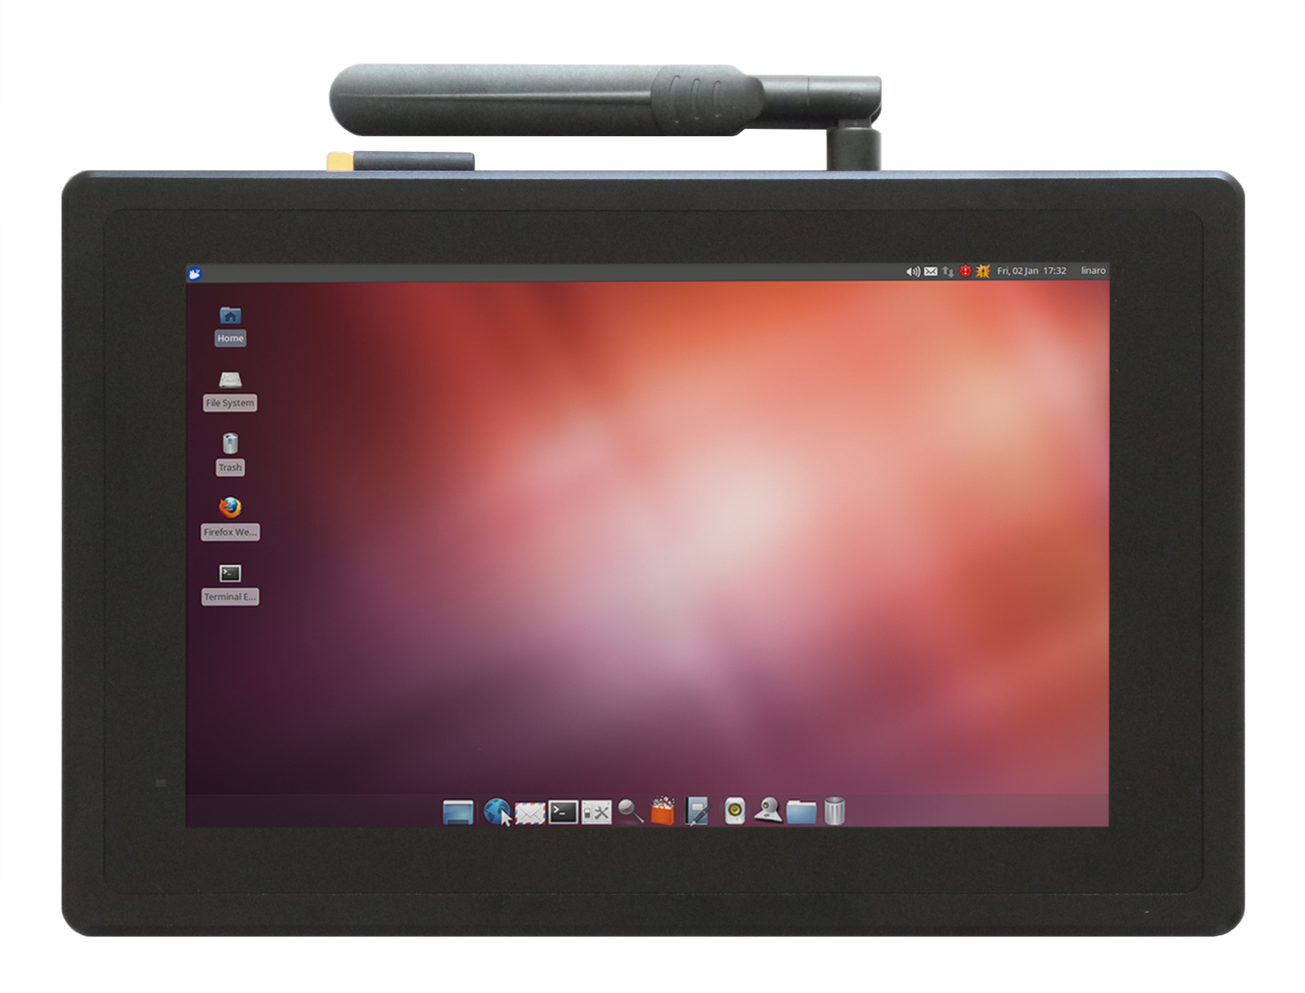
Figure 1 Top View (Ubuntu)

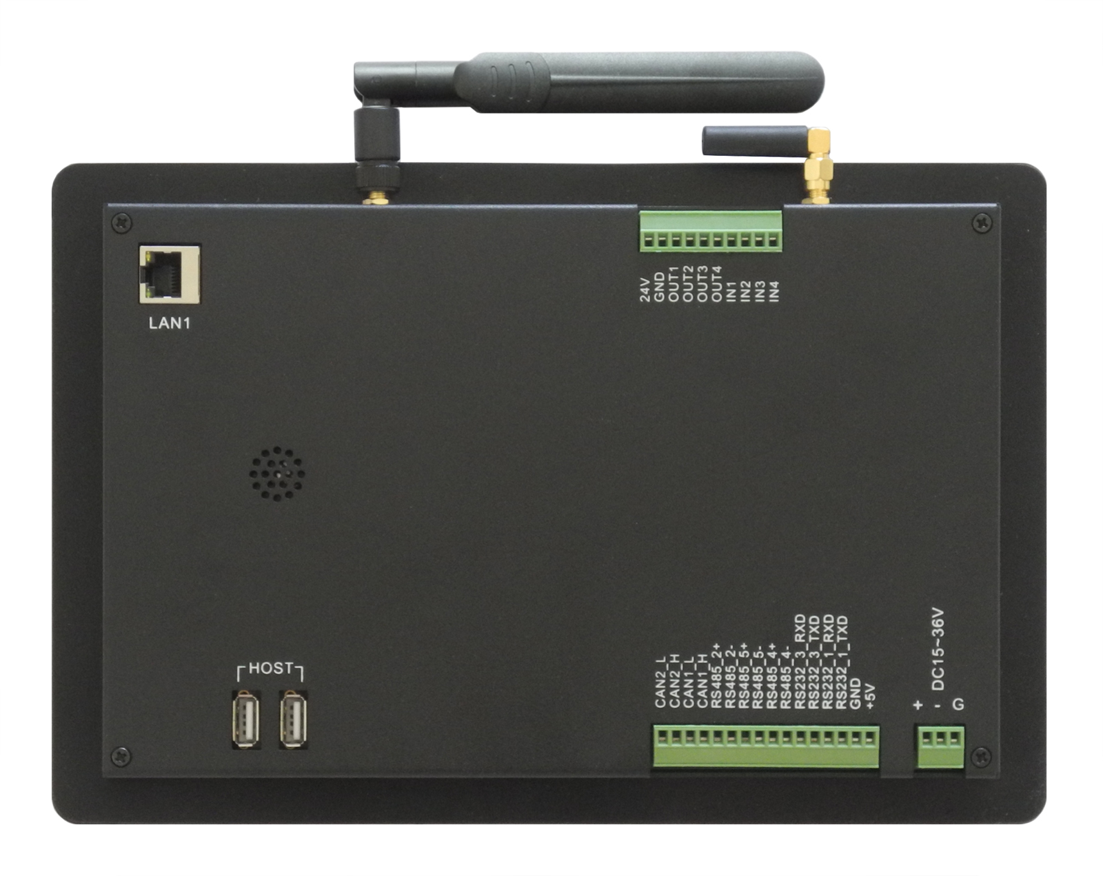
Figure 2 Back View

Power Input Connector
The product CS12800F101P-C141 uses a wide range power input: DC 12~36V. The total power consumption is about 7W normally. The Power Input Connector is 3 Pin 3.81mm Screw Terminal Connector as Figure 3 shows. The Character “+” means power Positive input, The Character “-” means power Negative input. The Character “G” means system Ground. Table 1 has detailed descriptions about the connector definition.

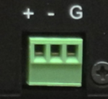
Figure 3 Power Input Connector
Table 1
Power Input Pin Definition:
Pin Number | Definition | Description
Pin 1 | Positive Input | Connect to DC Power Positive Terminal
Pin 2 | Negative Input | Connect to DC Power Negative Terminal
Pin 3 | Ground | Connect to Power System Ground

BE ATTENTION:
The system ground “G” has been connected to power negative “-” on board.

Capacitive Touch
The product CS12800F101P-C141 uses ten-point capacitive touch.
BE ATTENTION:
Capacitive touch is very sensitive to power noise. Ripple voltage/current from the power adapter will cause the LCD ripples, and will also cause the capacitive touch malfunction: If you use the APK Multi-Touch under Android to test, you can find the touch point float. There are several ways to solve this problem:
1) Use a high quality power adapter. Or use battery to provide the power like cell phone or tablet PC.
2) If user power adapter can’t be good enough, there’s another effective method to solve this problem: Make sure the CS12800F101P-C141 power input connector Pin 3 really connect to user “Power System Ground”. This method can eliminate the problem totally. User can also use another method to test this problem: touch the GND of CS12800F101P-C141 by one hand, the other hand operates on the capacitive touch screen. In this case, user’s body acts as the Power System Ground.

CAN+RS485+RS232 Connector
The CAN+RS485+RS232 connector is a 16 Pin 3.81mm Screw Terminal Connector, as Figure 4 shows. As for the definition of every pin, please refer to Table 2.This product has 5 channels of UART in total, they can be configured as RS232 or RS485 freely. If you need any other setting different to the default setting, please contact us.
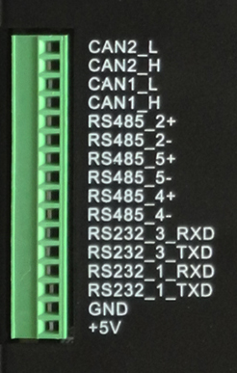
Figure 4 CAN+RS485+RS232 Connector
Table 2
RS232 / RS485 / CAN Pin Definition:
Pin Number | Definition | Description
Pin 1 | CAN2_L | CPU CAN Channel 2 L signal
Pin 2 | CAN2_H | CPU CAN Channel 2 H signal
Pin 3 | CAN1_L | CPU CAN Channel 1 L signal
Pin 4 | CAN1_H | CPU CAN Channel 1 H signal
Pin 5 | RS485_2+ | CPU UART2, RS485 +(B) signal
Pin 6 | RS485_2- | CPU UART2, RS485 -(A) signal
Pin 7 | RS485_5+ | CPU UART5, RS485 +(B) signal
Pin 8 | RS485_5- | CPU UART5, RS485 -(A) signal
Pin 9 | RS485_4+ | CPU UART4, RS485 +(B) signal
Pin 10 | RS485_4- | CPU UART4, RS485 -(A) signal
Pin 11 | RS232_3_RXD | CPU UART3, RS232 RXD signal
Pin 12 | RS232_3_TXD | CPU UART3, RS232 TXD signal
Pin 13 | RS232_1_RXD | CPU UART1, RS232 RXD signal
Pin 14 | RS232_1_TXD | CPU UART1, RS232 TXD signal
Pin 15 | GND | System Ground
Pin 16 | +5V | System +5V Power Output, No more than 1A Current output.

BE ATTENTION:
1. UART2 signal has been used by Bluetooth signal on board. The RS485_2 function has been disabled by default. If customer needs to use RS485_2 function, please contact us, we will disable the Bluetooth function.
2. All the CAN signal and RS485 signal have not mount on the 120Ohm Matched Resistance.

USB HOST Connector
The product CS12800F101P-C141 has two USB connectors as Figure 5 shows. These two USB can provide 500mA current each.
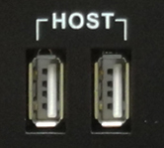
Figure 5 USB HOST Connector

USB OTG Connector
The product CS12800F101P-C141 has one USB OTG connector as Figure 6 shows. It works as slave by default. User can connect it to host PC by this connector.

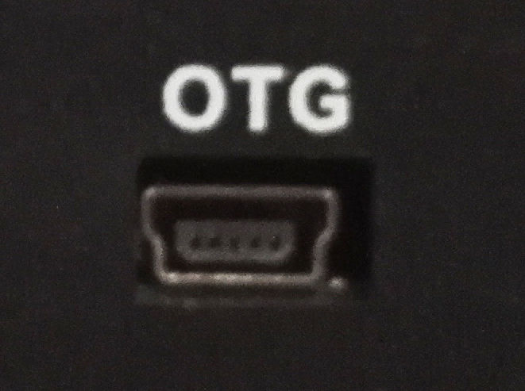
Figure 6 USB OTG Connector

LAN Connector
The product CS12800F101P-C141 has one channel 1000Mbit Ethernet Connector(LAN1), as Figure 7 shows. And this port support POE(Power-On-Ethernet).The other one channel 100Mbit Ethernet Connector is optional.
Figure 7 LAN Connector

TF Card
The product CS12800F101P-C141 has one TF(uSD) card connector as Figure 8 shows. This device supports TF(uSD) card up to 32GB.
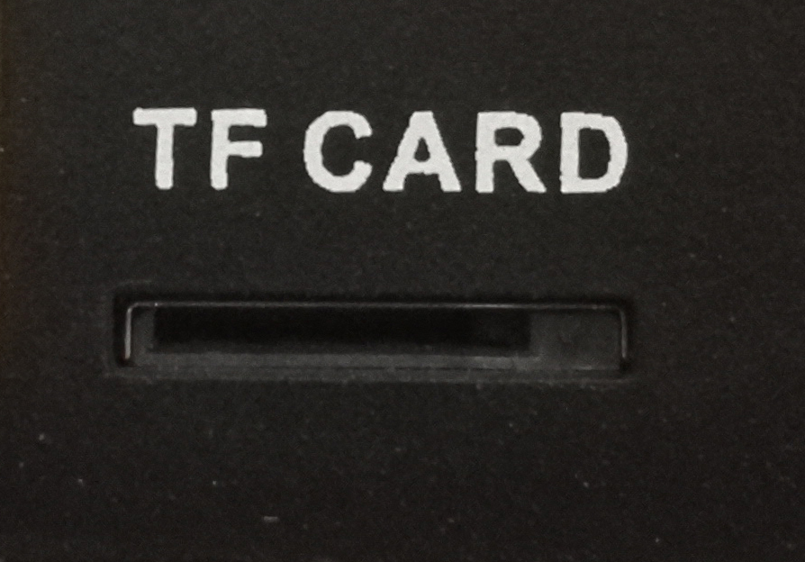
Figure 8 TF Card Connector
BE ATTENTION:
The TF card slot is NOT mounted with any TF card by default.

SIM Card Holder
The product CS12800F101P-C141 has a mini-PCIe connector inside, customer can mount on 4G module to it. Then it will need the SIM Card Holder, as Figure 9 shows. There is a connector on the backside case which can connect external 4G Antenna, as Figure 10 shows.

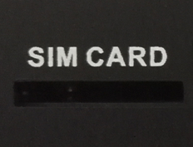
Figure 9 SIM Card Holder

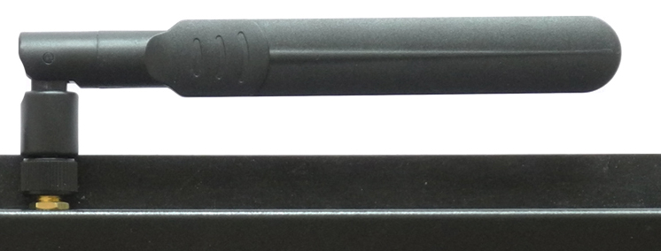
Figure 10 4G Antenna
BE ATTENTION:
This product is not mounted on any 4G module by default. And only Android 4.3 driver for 4G module is available at present.

Audio Connector
The product CS12800F101P-C141 has one Audio Input (“Line-in”) and one Audio (“Line-out”) output, as Figure 11shows. And the product has an internal 2W speaker.

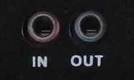
Figure 11 Audio Connector

WiFi+BT
The product CS12800F101P-C141 has one WiFi+BT. It uses Realtech RTL8723 which integrates WiFi and BT. There is a connector on the backside case which can connect external WiFi/BT Antenna, as Figure 12 shows.
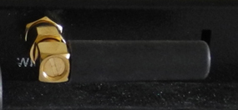
Figure 12 WiFi+BT Antenna

HDMI Connector
The product CS12800F101P-C141 has one HDMI connector as Figure 13 shows. The HDMI output resolution can be configured by software.
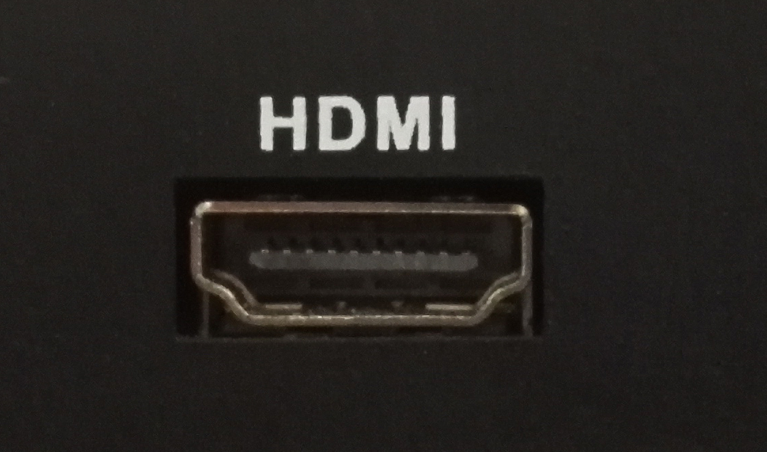
Figure 13 HDMI Connector

Boot Switch
The product CS12800F101P-C141 has a boot switch which can be used to change boot sequence, as Figure 14 shows. It is defined as SW2 on the PCB. As for the details of the boot switch, please refer to Table 3.

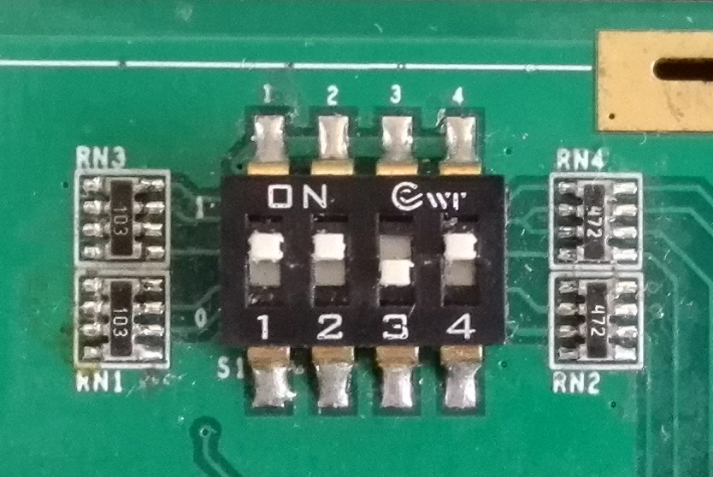
Figure 14 Boot Switch
Table 3
Boot Config Select:
Mode | 1 | 2 | 3 | 4
TF Card | 1 | 0 | 0 | 0
eMMC | 1 | 1 | 0 | 1
Download | 0 | 1 | 1 | 0

GPIO Connector
The product CS12800F101P-R141 has one GPIO Connector, as Figure 15 shows. This connector is labelled as P28 on the PCB.. As for the definition of every Pin, please refer to Table 4.

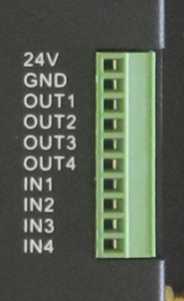
Figure 15 GPIO Connector
Table 4
GPIO Connector Definition
Pin Number | Definition
Pin 1 | VCC, Isolated Power +5-24V Input
Pin 2 | GND
Pin 3 | OUT1
Pin 4 | OUT2
Pin 5 | OUT3
Pin 6 | OUT4
Pin 7 | IN1
Pin 8 | IN2
Pin 9 | IN3
Pin 10 | IN4

BE ATTENTION:
All these signals connect to CPU directly. Please use it carefully, or the CPU will be damaged easily.

Camera
The Product CS12800F101P-C141 supports one channel CMOS camera. User should open the product’s backside case then can find the camera connector, as Figure 16 shows. It labelled as P26 on the PCB. It can support camera OV2659, OV5640.
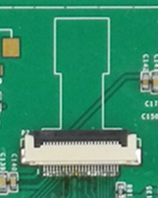
Figure 16 Camera Connector

Measurements and Mounting

Measurements
The measurement of CS12800F101P-C141 is 280*185.5*27.5mm, as Figure 17 shows.
Figure 17 Dimension

Mounting Method
This product CS12800F101P-C141 can be mounted using the mounting set, as Figure 18 shows. Please make sure the display is not exposed to high pressure when mounting into an enclosure.
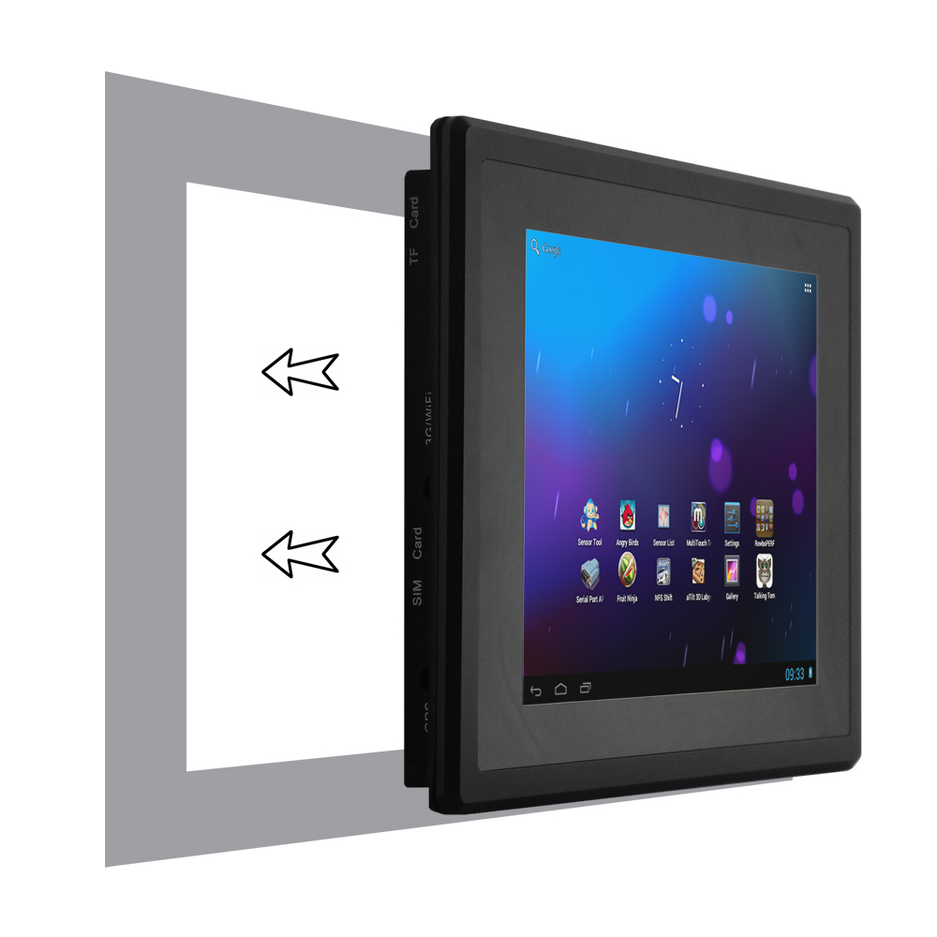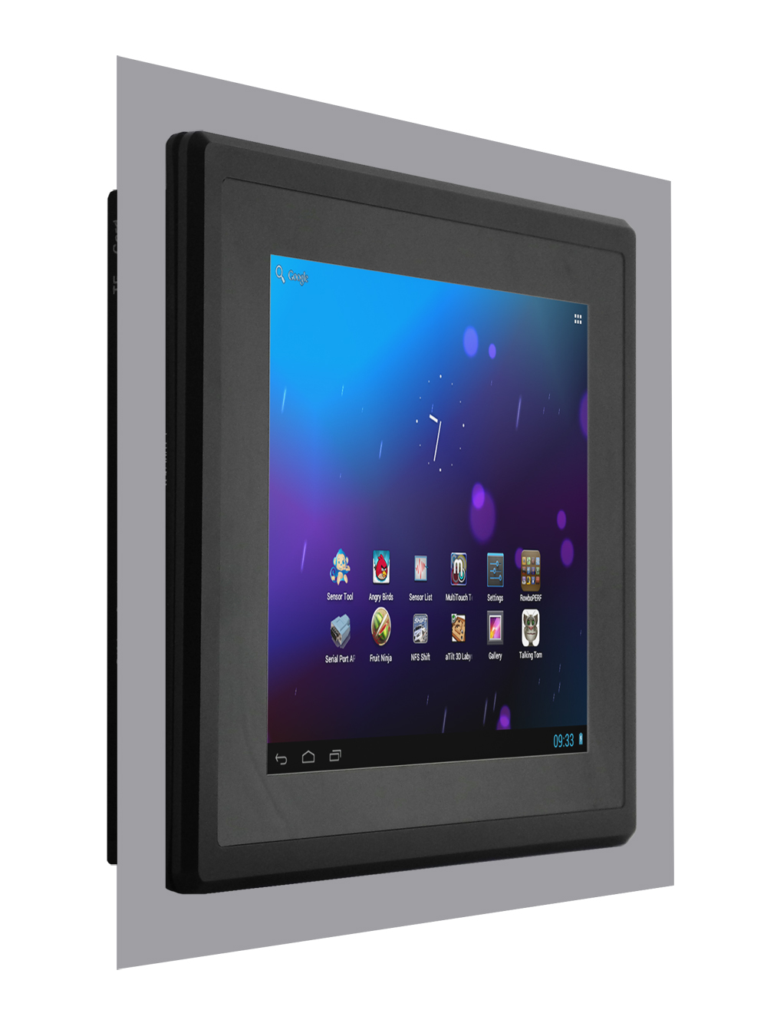
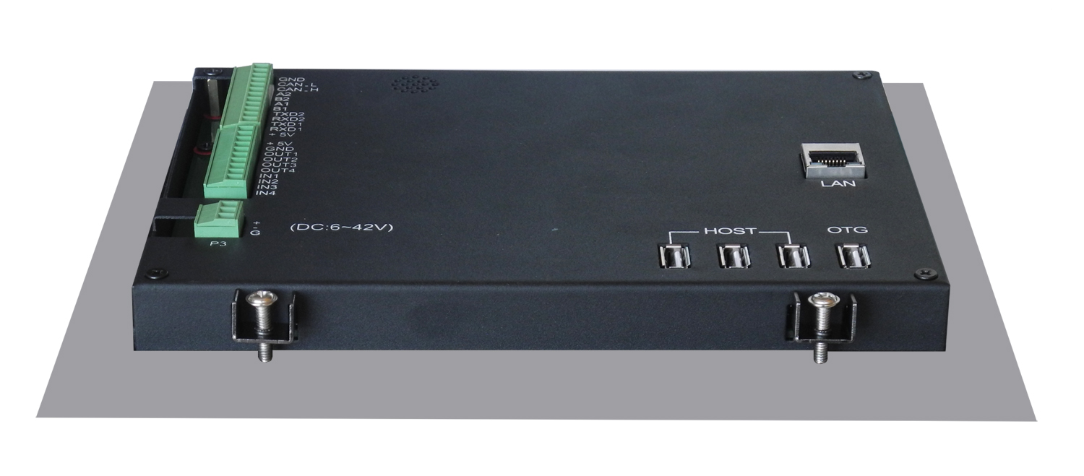
Figure 18 Mounting Method

How to Get Support
Please feel free to contact us with any questions, queries or suggestions.
If your question is about technical support or troubleshooting for one of our products, we kindly ask you to first check our documentation for a possible solution.
If you cannot find the solution you are looking for then please write to service@chipsee.com providing all possible details.

© Chipsee all right reserved.

Chipsee assumes no responsibility for any errors, which may appear in this manual. Furthermore, Chipsee reserves the right to alter the hardware, software, and/or specifications detailed herein at any time without notice, and does not make any commitment to update the information contained herein. Chipsee products are not authorized for use as critical components in life support devices or systems.

